|  |  |
| --- | --- |
|  | **Computer Organization & Assembly Language**  **BSCS-3**  **Department of Computer Science**  **Bahria University, Lahore Campus** |

**Assignment: [1]**

Date: Week 3, 12th March 2023

Name: _AFFAN AHMAD_____

Roll No: _03-134221-003_______

|  |  |  |  |
| --- | --- | --- | --- |
| **Evaluation of CLO** | **Question Number** | **Marks** | **Obtained Marks** |
| **CLO1: Develop an understanding of the underlying concepts of Assembly language.** | 1 | 6 |  |
| 2 | 5 |  |
| 3 | 5 |  |
| 4 | 4 |  |
| **Total Marks** | | **20** |  |

**Question 1: [Marks: 6]**

A memory location has a physical address 5BA00h. Compute

1. The offset address if the segment number is 51ACh. [2]
2. The segment number if the offset address is 4D10h? [2]
3. Determine the physical address of a memory location given by 70F6:1BC0h. [2]

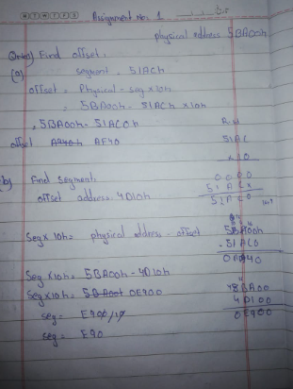

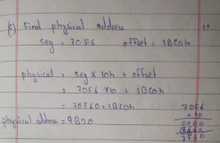

**Question 2: [Marks: 5]**

What is the binary representation of D5B7h? Also calculate the unsigned and signed decimal interpretation of this number.

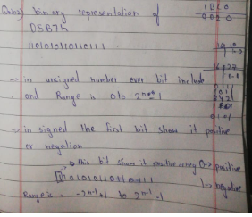

**Question 03:** Using only basic arithmetic instructions, translate the given statement into assembly language.

Assume A, B and C are word variables: **[Marks: 5]**

A = B + 2 – (C*2)

.data

o: .asciiz "Enter b number :"

o1:.asciiz "Enter c number :"

result: .asciiz "the result is :"

.text

la $a0, o

li $v0, 4

syscall

li $v0,5

syscall

move $s0,$v0

la $a0, o1

li $v0, 4

syscall

li $v0,5

syscall

move $s1,$v0

mul $t0, $s1, 2

add $t1, $s0,2

sub $t1,$t1,$t0

li $v0, 4

la $a0, result

syscall

li $v0, 1

move $a0, $t1

syscall

li $v0,10

syscall

**Question 04:** Perform the following addition or subtraction: **[Marks: 4]**

a. FE02h + 1E01h (2)

b. 10110100b – 10010111b

